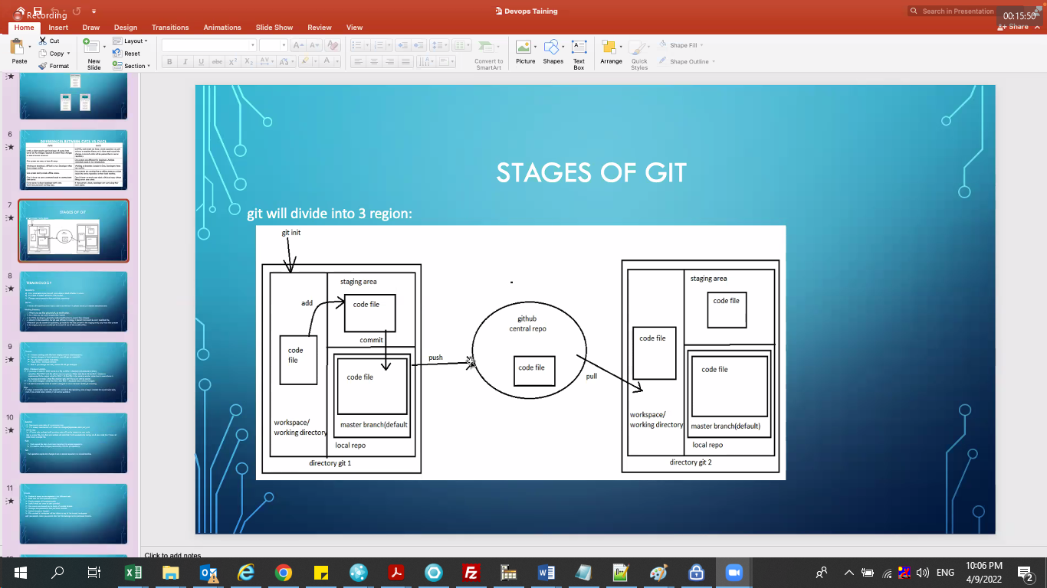

https://jira.atlassian.com

https://github.com/ravivarma4ever/testdemo

https://bitbucket.org/dashboard/overview